Testing Report

“chillington”

Cooper Deguet, Deklan Gentile, Isaac Thyer

2022

Contents

Issue 1 – “Waves don’t increase in difficulty” 2

Summary 2

Reproducibility 2

Relevant Information 2

Full Bug Report 2

Issue 2 – “Knife was too overpowered” 3

Summary 3

Reproducibility 3

Relevant Information 3

Full Bug Report 3

Issue 3 – “Zombie Pathfinding Broken” 4

Summary 4

Reproducibility 4

Relevant Information 4

Full Bug Report 4

Signature 5

# Issue 1 – “Waves don’t increase in difficulty”

## Summary

*In game wave spawner for zombies was intended to increase in difficulty as the rounds progressed, this was shown to not work as intended through testing as play testers said that the game was too easy.*

## Reproducibility

*Start the executable file for the game, click the start button, play the game and the waves will not increase in difficulty.*

## Relevant Information

*N/A*

## Full Bug Report

Testers Name: Isaac Thyer

Date: *25/10/2023*

Feature: *The difficulty of the waves of zombies spawned throughout the game.*

Bug: *“Zombie wave spawning was too easy as the amount of zombies spawned was not enough”*

Reproducible: *“Yes”*

What you did: *“ran the executable game file”*

Expected Outcome: *The amount of zombies should have increased each round as the player continued to play.*

Actual Outcome: *The zombie spawn amount did not increase like intended.*

Urgency: *“Less urgent”*

Environment*: “2”*

Description: *When playing the game, the number of zombies which spawned each round was too little for a challenging and enjoyable experience. When playtesting with other groups each person who tried the game gave feedback on the lack of difficulty with the game. The issue of the number of zombies spawning each round was found whilst personally play testing the game.*

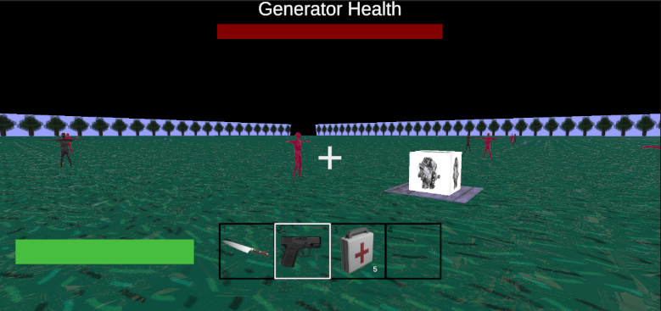Reproduction: Start Executable, click start on UI menu, Play game.

Screenshots:

# Issue 2 – “Knife was too overpowered”

## Summary

*Knife weapon was too strong and able to kill zombies with too much ease without any risk*

## Reproducibility

*Start the executable file for the game, click the start button, switch item holding to knife, use on zombie.*

## Relevant Information

*N/A*

## Full Bug Report

Testers Name: Cooper Deguet

Date: *01/11/2023*

Feature: *The details and usage of the knife made it way too powerful*

Bug: *“Knife is way too powerful, and allows for person playing to make the game easy*

Reproducible: *Yes*

What you did: *ran the executable game file and played the game, then used the knife on a zombie*

Expected Outcome: *The knife was expected to provide a risky way to get a kill on a zombie*

Actual Outcome: *The range of the knife allowed for the player to use this weapon with no risk.*

Urgency: *decently urgent*

Environment*: 3*

Description: *When playing the game, if the person playing switches to using the knife then the game becomes far too easy as the range of the knife was too great. Quite quickly the people play testing the game realized that it was the best way to win the game.*

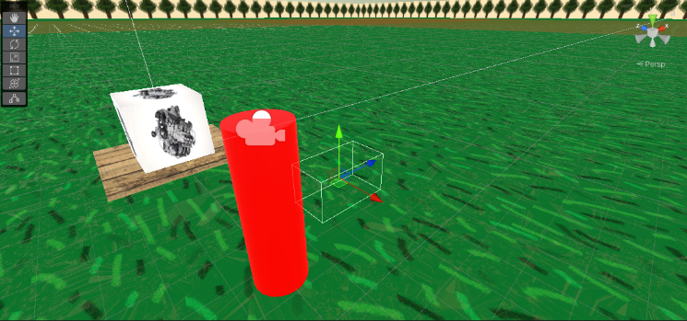Reproduction: Start executable, click on start in menu UI, switch to using the knife, wait for night time and for the zombies to spawn, use knife on zombies until it doesn’t become to easy.

Screenshots:

# Issue 3 – “Zombie pathfinding broken”

## Summary

*When the fence upgrade was bought in the game, the zombies would walk through it instead of avoiding the obstacle.*

## Reproducibility

*Play the game and collect 10 metal to buy fences (or change metal value on crafting UI gameobject) buy fence, the enemy would walk through the fence.*

## Relevant Information

*Bug would only affect enemy, not player.*

## Full Bug Report

Testers Name: Deklan Gentile

Date: *25/10/2023*

Feature: *The pathfinding of the enemy zombie AI.*

Bug: *“Give the bug a descriptive name”*

Reproducible: *Yes*

What you did: *Played the game and bought the fence upgrade.*

Expected Outcome: *The zombie should have avoided the obstacle*

Actual Outcome: *The zombie walked through the fence, ignoring the obstacle.*

Urgency: *Fairly urgent*

Environment*: 3*

Description: *The bug would cause the fences to be a waste of metal in the game. Also making the defense mechanism useless.*

Reproduction: play the executable, click start button, play and collect 10 metal, click tab to open craft menu, click on the fence to buy, watch zombie walk through.

Screenshots: 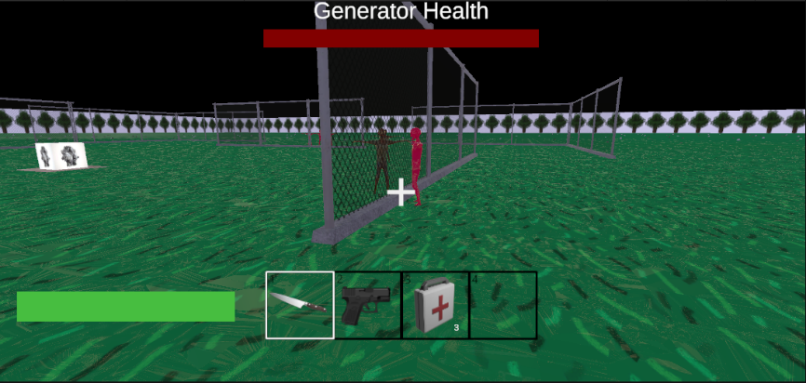

# Signature

This report has been read and received by the team.

